

# Melville Senior High School

### Semester Two Examination, 2019

### Question/Answer booklet

# MATHEMATICS

**SOLUTIONS**

**METHODS**

**UNITS 1 AND 2**

## Section One:

## Calculator-free

|  |  |  |  |  |  |  |  |  |  |  |
| --- | --- | --- | --- | --- | --- | --- | --- | --- | --- | --- |
| Student number: In figures |  |  |  |  |  |  |  |  |  |  |

In words

Your name

## Time allowed for this section

Reading time before commencing work: five minutes

Working time: fifty minutes

## Materials required/recommended for this section

***To be provided by the supervisor***

This Question/Answer booklet

Formula sheet

***To be provided by the candidate***

Standard items: pens (blue/black preferred), pencils (including coloured), sharpener,  
correction fluid/tape, eraser, ruler, highlighters

Special items: nil

## Important note to candidates

No other items may be taken into the examination room. It is **your** responsibility to ensure that you do not have any unauthorised material. If you have any unauthorised material with you, hand it to the supervisor **before** reading any further.

## Structure of this paper

|  |  |  |  |  |  |
| --- | --- | --- | --- | --- | --- |
| Section | Number of questions available | Number of questions to be answered | Working  time (minutes) | Marks available | Percentage of examination |
| Section One:  Calculator-free | 8 | 8 | 50 | 52 | 35 |
| Section Two:  Calculator-assumed | 13 | 13 | 100 | 98 | 65 |
|  | | |  | **Total** | 100 |

## Instructions to candidates

1. The rules for the conduct of examinations are detailed in the school handbook. Sitting this examination implies that you agree to abide by these rules.

2. Write your answers in this Question/Answer booklet preferably using a blue/black pen.  
Do not use erasable or gel pens.

3. You must be careful to confine your answer to the specific question asked and to follow any instructions that are specified to a particular question.

4. Show all your working clearly. Your working should be in sufficient detail to allow your answers to be checked readily and for marks to be awarded for reasoning. Incorrect answers given without supporting reasoning cannot be allocated any marks. For any question or part question worth more than two marks, valid working or justification is required to receive full marks. If you repeat any question, ensure that you cancel the answer you do not wish to have marked.

5. It is recommended that you do not use pencil, except in diagrams.

6. Supplementary pages for planning/continuing your answers to questions are provided at the end of this Question/Answer booklet. If you use these pages to continue an answer, indicate at the original answer where the answer is continued, i.e. give the page number.

7. The Formula sheet is not to be handed in with your Question/Answer booklet.

Section One: Calculator-free 35% (52 Marks)

This section has**eight (****8)** questions. Answer **all** questions. Write your answers in the spaces provided.

Working time: 50 minutes.

Question 1 (4 marks)

The line segment between the points $A(-1, -2)$ and $B(-1, 8)$ is the diameter of a circle.

Determine the equation of circle in the form $x^{2}+ax+y^{2}+by=c$, where $a, b$ and $c$ are constants.

|  |
| --- |
| **Solution** |
| Centre: $\left(-1, \frac{-2+8}{2}\right)=(-1, 3)$ Radius: $r=8-3=5$ Equation: ${\left(x+1\right)}^{2}+{\left(y-3\right)}^{2}=5^{2}$ $$x^{2}+2x+1+y^{2}-6y+9=25 \\ x^{2}+2x+y^{2}-6y=15$$ |
| **Specific behaviours** |
| ✓ centre  ✓ radius  ✓ factored equation  ✓ correct equation |

Question 2 (5 marks)

Determine the gradient of the curve $y=x^{2}-3x-40$ at the point(s) where it crosses the $x$-axis.

|  |
| --- |
| **Solution** |
| $$\left(x+5\right)\left(x-8\right)=0 \\ x=-5, x=8$$ $$\frac{dy}{dx}=2x-3$$ $$x=-5,\frac{dy}{dx}=-13$$ $$x=8,\frac{dy}{dx}=13$$ At $(-5, 0)$ gradient is $-13$ and at $(8, 0)$ gradient is $13$. |
| **Specific behaviours** |
| ✓ factorises quadratic  ✓ determines roots  ✓ derivative of quadratic  ✓ one point and gradient  ✓ second point and gradient |

Question 3 (7 marks)

Small body $A$ is moving along a straight line so that at any time $t$ seconds, its displacement relative to a fixed point $O$ on the line is given by $x=t^{3}-3t^{2}+5$ cm.

(a) Determine the velocity of $A$ when $t=3$. (2 marks)

|  |
| --- |
| **Solution** |
| $$v=\frac{dx}{dt}=3t^{2}-6t$$ $$v\left(3\right)=3{\left(3\right)}^{2}-6\left(3\right) \\ =9 \text{cm/s}$$ |
| **Specific behaviours** |
| ✓ expression for velocity  ✓ correct velocity |

(b) Determine the displacement of $A$ relative to $O$ at the instant(s) that it is stationary.

(3 marks)

|  |
| --- |
| **Solution** |
| $$3t^{2}-6t=0 \\ 3t\left(t-2\right)=0 \\ t=0, t=2$$ $$x\left(0\right)=5 \text{cm}, x\left(2\right)=1 \text{cm}$$ |
| **Specific behaviours** |
| ✓ factorises velocity  ✓ one correct displacement  ✓ both correct displacements |

Small body $B$ has velocity given by $v=6t^{2}+2t-3$ cm/s and when $t=2$ it has a displacement of $3$ cm relative to $O$.

(c) Determine an expression for the displacement of $B$ relative to $O$ at any time $t$. (2 marks)

|  |
| --- |
| **Solution** |
| $$\frac{dx}{dt}=6t^{2}+2t-3 \\ x=2t^{3}+t^{2}-3t+c$$ $$c=3-\left(16+4-6\right)=-11$$ $$x=2t^{3}+t^{2}-3t-11$$ |
| **Specific behaviours** |
| ✓ antidifferentiates  ✓ correct expression |

Question 4 (8 marks)

(a) Simplify $(3a+2\sqrt{a})(3a-2\sqrt{a})$. (2 marks)

|  |
| --- |
| **Solution** |
| $$\left(3a+2\sqrt{a}\right)\left(3a-2\sqrt{a}\right)={\left(3a\right)}^{2}-{\left(2\sqrt{a}\right)}^{2} \\ =9a^{2}-4a$$ |
| **Specific behaviours** |
| ✓ indicates use of difference of squares  ✓ correct simplification |

(b) Solve the equation $8^{x}=\begin{matrix}\sqrt{2} \\ \overline{32}\end{matrix}$ for $x$. (3 marks)

|  |
| --- |
| **Solution** |
| $${\left(2^{3}\right)}^{x}=2^{0.5}×2^{-5} \\ 2^{3x}=2^{-4.5} \\ 3x=-4.5 \\ x=-1.5=-\frac{3}{2}$$ |
| **Specific behaviours** |
| ✓ writes $8$ and $32$ as powers of $2$ ✓ simplifies RHS  ✓ correct solution |

(c) Sketch the graph of $y=2^{(1-x)}$ on the axes below. (3 marks)

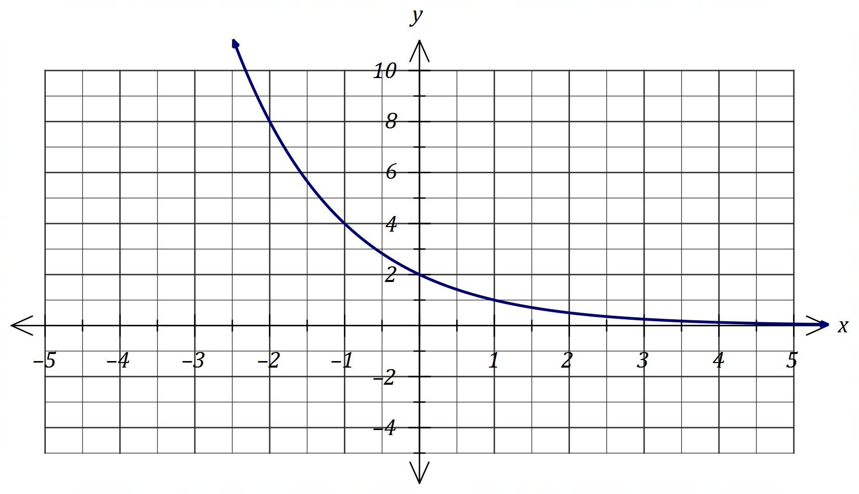

|  |
| --- |
| **Solution** |
| See graph |
| **Specific behaviours** |
| ✓ -intercept  ✓ RHS of $y$-axis (asymptotic)  ✓ LHS of $y$-axis (through $[-2, 8]$) |

Question 5 (7 marks)

(a) Using Pascal's triangle, or otherwise, determine $\left(\begin{matrix}4 \\ 3\end{matrix}\right)$. (1 mark)

|  |
| --- |
| **Solution** |
| $$\left(\begin{matrix}4 \\ 3\end{matrix} \right)=4$$ |
| **Specific behaviours** |
| ✓ correct value |

(b) Expand ${\left(x-1\right)}^{4}$. (2 marks)

|  |
| --- |
| **Solution** |
| $${\left(x+1\right)}^{4}=x^{4}+4x^{3}(-1)+6x^{2}{\left(-1\right)}^{2}+4x{\left(-1\right)}^{3}+{\left(-1\right)}^{4} \\ =x^{4}-4x^{3}+6x^{2}-4x+1$$ |
| **Specific behaviours** |
| ✓ uses Pascal's triangle for coefficients  ✓ correct expansion |

(c) Hence, or otherwise, determine the equation of the tangent to the curve $y={\left(x-1\right)}^{4}$ at the point where $x=2$. (4 marks)

|  |
| --- |
| **Solution** |
| $$\frac{dy}{dx}=4x^{3}-12x^{2}+12x-4$$ When $x=2$ $$y={\left(1\right)}^{4}=1$$ $$\frac{dy}{dx}=32-48+24-4=4$$ Hence equation of tangent is $$y-1=4\left(x-2\right)$$ or $$y=4x-7$$ |
| **Specific behaviours** |
| ✓ derivative $y$ ✓ -coordinate  ✓ gradient  ✓ equation of tangent (any form) |

Question 6 (8 marks)

(a) Solve the following equations.

(i) $\tan{(2x)}=\sqrt{3}$, $0≤x≤π$. (2 marks)

|  |
| --- |
| **Solution** |
| $$2x=\frac{π}{3},\frac{4π}{3}$$ $$x=\frac{π}{6},\frac{2π}{3}$$ |
| **Specific behaviours** |
| ✓ one correct solution  ✓ both correct solutions |

(ii) $2\cos{(x-60°)}=\sqrt{3}+\cos{x}$, $0°≤x≤360°$. (4 marks)

|  |
| --- |
| **Solution** |
| $$2\left(\cos{x}\cos{60°}+\sin{x}\sin{60°}\right)=\sqrt{3}+\cos{x} \\ 2\left(\cos{x}\left(\frac{1}{2}\right)+\sin{x}\left(\frac{\sqrt{3}}{2}\right)\right)=\sqrt{3}+\cos{x} \\ \sin{x}=1 \\ x=90°$$ |
| **Specific behaviours** |
| ✓ uses angle difference identity  ✓ substitutes exact values  ✓ simplifies equation  ✓ correct solution |

(b) The graph of $y=\sin{(ax+b)}$ is shown below, where $a$ and $b$ are positive constants.

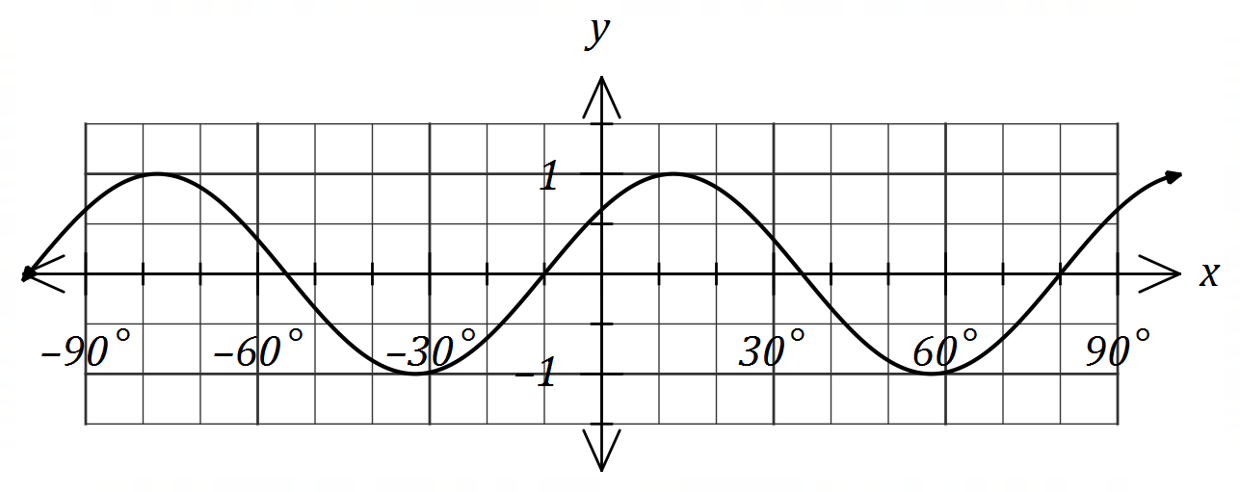

Determine the minimum possible value of each of the constants. (2 marks)

|  |
| --- |
| **Solution** |
| Period of $90°⇒a=360°÷90°=4$ $$y=\sin\left(4\left(x+10\right)\right)=\sin\left(4x+40°\right)$$ $$a=4, b=40°$$ |
| **Specific behaviours** |
| ✓ value of $a$ ✓ value of $b$ |

Question 7 (6 marks)

Determine the coordinates of all stationary points of the curve $y=x^{4}+2x^{2}-8x+9$.

|  |
| --- |
| **Solution** |
| $$\frac{dy}{dx}=4x^{3}+4x-8$$ $$4x^{3}+4x-8=0$$ $$x^{3}+x-2=0$$ By inspection, $x=1$ is a solution. $$x^{3}+x-2=(x-1)(x^{2}+ax+2)$$ From $x^{2}$ coefficient: $-1+a=0⇒a=1$ $$x^{2}+x+2=0$$ $$b^{2}-4ac=1-4\left(1\right)\left(2\right)=-7⇒\text{No solutions}$$ $$y=1+2-8+9=4$$ Hence just one stationary point at $(1, 4)$. |
| **Specific behaviours** |
| ✓ derivative  ✓ equates derivative to $0$ ✓ one solution by inspection  ✓ factorises derivative  ✓ indicates quadratic factor has no roots  ✓ states coordinates of stationary point |

Question 8 (7 marks)

An arithmetic sequence has a recursive definition given by $T_{n+1}=T_{n}+d, T_{1}=a$. It has third term of $40$ and tenth term of $12$.

(a) Determine the value of the constant $a$ and the constant $d$. (2 marks)

|  |
| --- |
| **Solution** |
| $$\left(10-3\right)d=12-40$$ $$7d=-28$$ $$d=-4$$ $$a=40-2\left(-4\right)=48$$ |
| **Specific behaviours** |
| ✓ value of $d$ ✓ value of $a$ |

(b) Determine $T_{2019}$. (2 marks)

|  |
| --- |
| **Solution** |
| $$T_{n}=48+\left(n-1\right)\left(-4\right)$$ $$T_{201}=48+2018\left(-4\right)$$ $$=-8 024$$ |
| **Specific behaviours** |
| ✓ indicates rule for general term  ✓ correct value |

(c) The sum of the first $m$ terms of the sequence is $200$. Determine the value(s) of the integer constant $m$. (3 marks)

|  |
| --- |
| **Solution** |
| $$200=\frac{m}{2}\left(2\left(48\right)+\left(m-1\right)\left(-4\right)\right) \\ 400=m\left(96-4m+4\right) \\ 4m^{2}-100m+400=0 \\ m^{2}-25m+100=0 \\ \left(m-5\right)\left(m-20\right)=0$$ $$m=5, m=20$$ |
| **Specific behaviours** |
| ✓ substitutes into sum formula  ✓ simplifies and equates quadratic to zero  ✓ both correct solutions |

Supplementary page

Question number: _________

© 2019 WA Exam Papers. Melville Senior High School has a non-exclusive licence to copy and communicate this document for non-commercial, educational use within the school. No other copying, communication or use is permitted without the express written permission of WA Exam Papers. SN063-142-3.